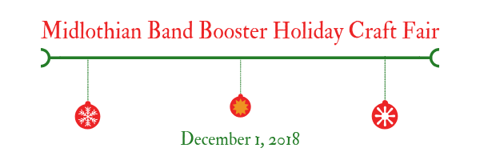

Dear Vendor,

Thank you for your participation in the Midlothian Band Booster 3rd Annual Holiday Craft Fair Fundraiser. This is an important fundraiser for our band students. The money raised goes to benefit band students’ events, activities, rewards, private lesson scholarships, band camp supplements, and clinics.

This letter confirms your reservation for Saturday, December 1, 2018. Following you’ll find information you’ll need for this event.

Temporary Food Establishment Permit:
The city of Midlothian requires anyone selling or sampling food or drinks during our event must have a temporary food establishment permit. Unfortunately, this permit is also required for any free candy or drinks that you would have sitting on your table for customers to eat.

The cost of the permit is $30 and is due to the city by 5pm on Wed, Nov 28th. They only take exact cash or check. There is no credit card option to pay. You'll find the attached application below. If you choose to forgo having any food or drinks available to customers, then you do not need a permit.

Set Up/Tear Down:
You may set up Friday, November 30 between 7 pm - 9 pm and/or Saturday morning between 7 am - 9 am. Before unloading, you will need to check in at the registration table in the cafeteria to get your booth assignment. You may unload your wares at the cafeteria entrance (in the back of the parking lot that enters from Walter Stephenson Rd - see site map attached). We will have some students and Band Booster parents to assist you during these times. They will also be available to help you load back up on Saturday after the show closes.

Booth Space:
We have a limited number of 6-foot tables that will be available on a first come first served basis. We will provide 1-2 chairs per booth. If you have requested electrical access, we will do our best to accommodate but these spaces will be available on a first come first served basis as well. We have had some requests for booth placements which we will do our best to accommodate. All other spaces are first come first served. All vendors will be set up on the main floor in the cafeteria.

Raffle/Silent Auction:
To assist in our fundraiser, we ask that each vendor donate an item to our raffle ($10-$15 value). Someone will stop by to pick up these items on Saturday morning. While a raffle item donation is required, silent auction item donations are optional. If you are interested in donating to the silent auction, please respond to this email and let me know and I will connect you with Darshawn, who is heading that up. We ask that silent auction items be valued at or above $25.

Vendor Lunches/Concessions:
We have created a lunch meal especially for vendors for $5 each. Attached is a meal order form. If you would like to order a meal and have it delivered to your booth, please respond to this email with your request so we can plan accordingly. We will collect forms and payments on Saturday morning. We will have complimentary coffee and donuts Saturday from 7 - 9 am during set up.

Promotion:
I have attached maps and a flyer to help you promote the show in your area. We have set up a Facebook event https://www.facebook.com/events/251064835550923/?ti=icl. Please share this event and invite your friends. You can also find information on our booster website - www.midlothianbandboosters.org/craft-fair. We are doing our best to get the word out through several avenues but need your help as well.

I hope you find this email helpful. If you have any questions, please call/text or email me at the information below:

I look forward to meeting you!

Thanks so much!
Wanda Seibert / MBB Craft Fair Coordinator
midlothiancraftfair@gmail.com

